> 2017 is crazy weird: the answers are mostly likely wrong. do +1 if you agree to the answer, or post an alternative if not

1. A)

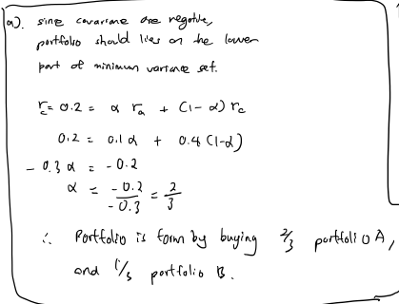

B)

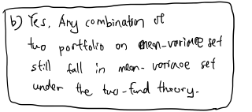

C)

Attempt 1:

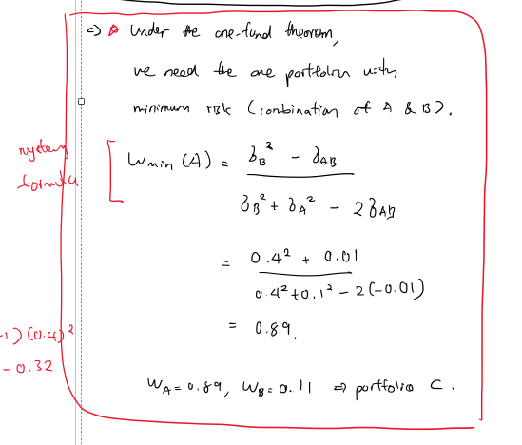

Attempt 2: formulate an optimization question, then solve it for w.

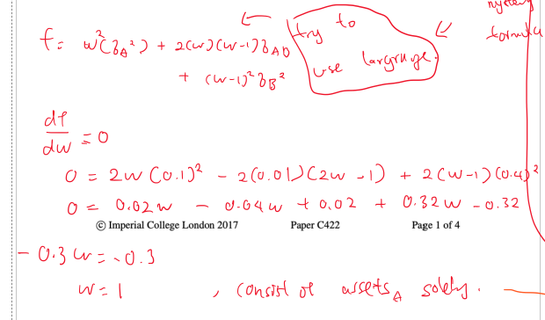

Attempt 3: another optimization formula that try to maximise gain too.

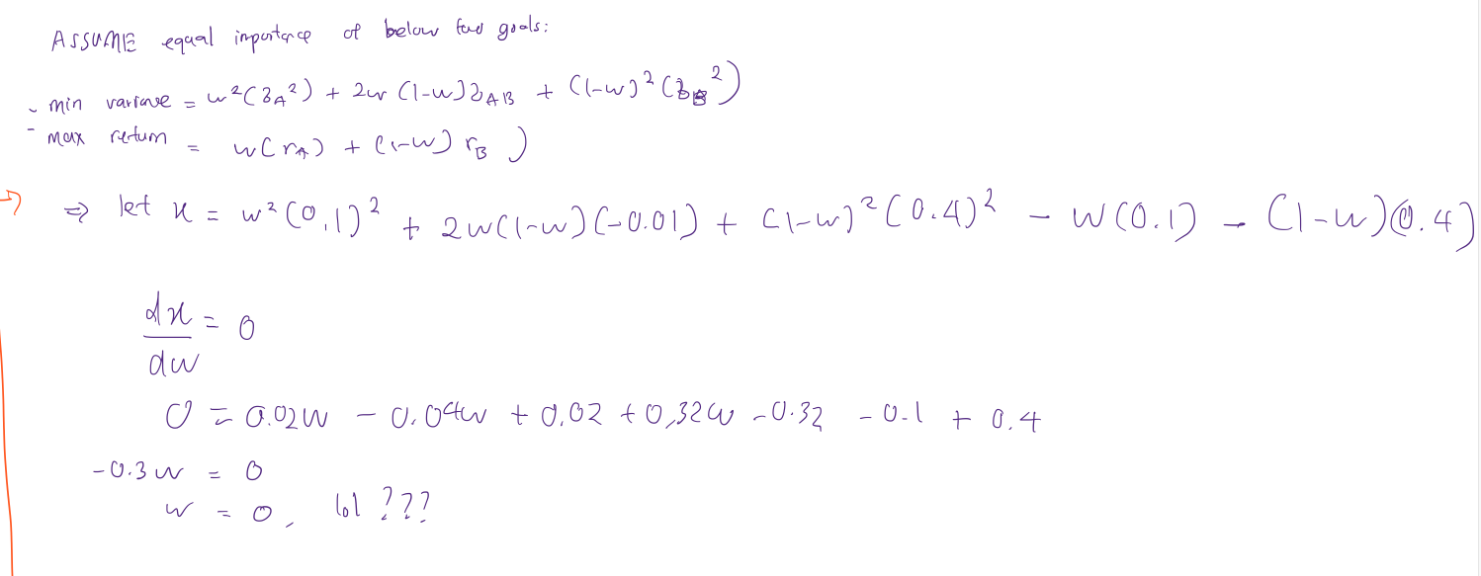  
**Do you think that we can use the covariance of a and b from part a):**  
**Yes: 4**  
**No: 1**

Attempt 4:

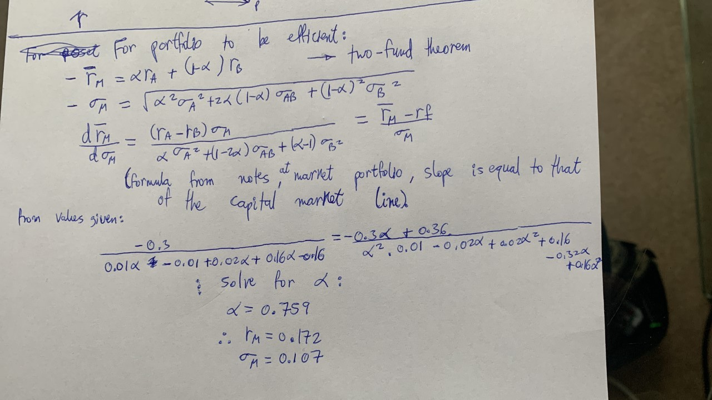

Attempt 5:

Follow the method in the follow-up for a similar question?: <https://piazza.com/class/kf7ugu9mit5ub?varcid=211>.

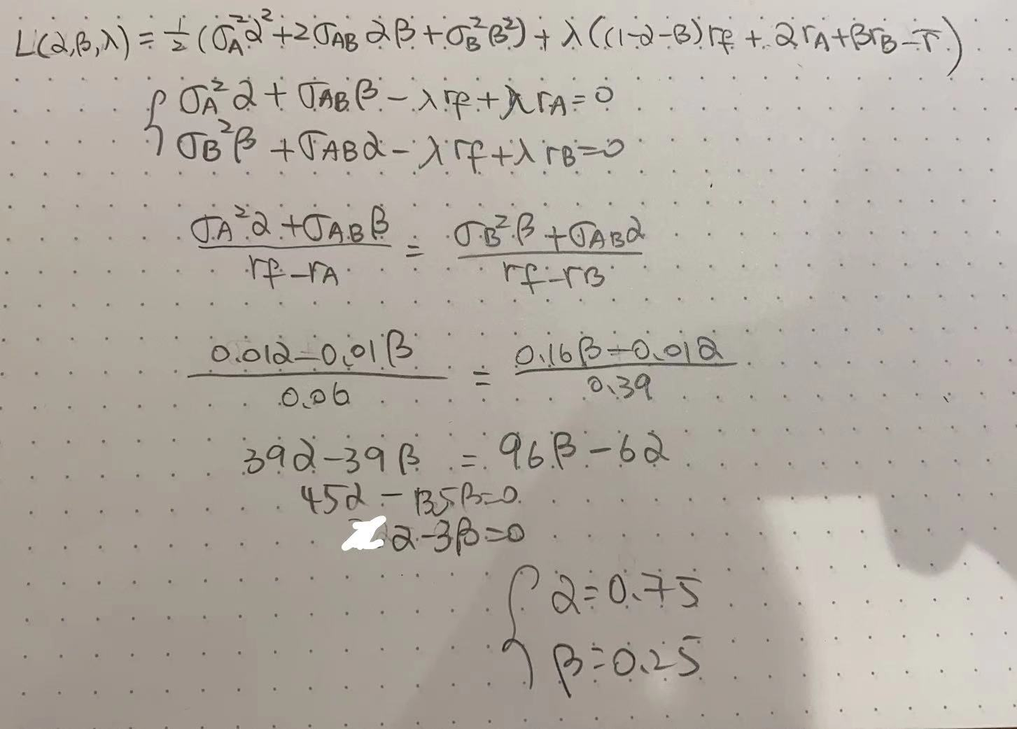

D)

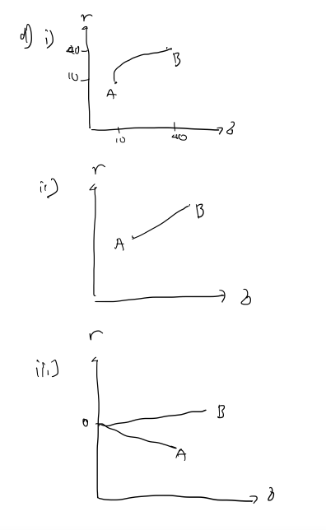

2) A) Done before. See other past year.

B)

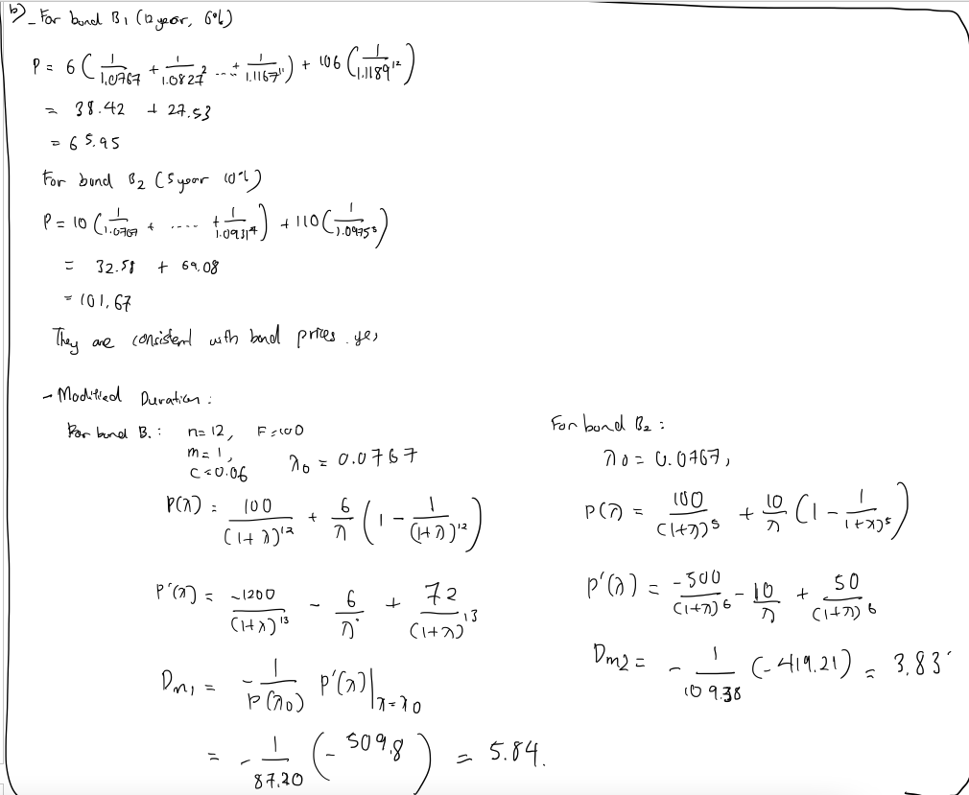

C)

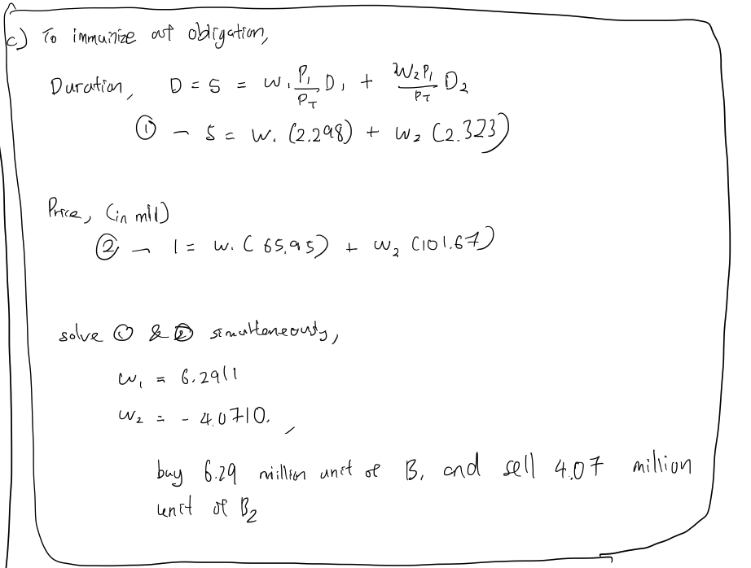

3) A)

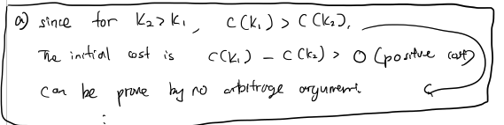

B)

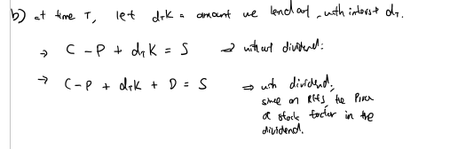

C) Done before.

D) Done before. Where ?

E) When interest rate is zero. When there is only one time period left.

4)

A) 1, C = 1

B) -2/3, C = 3/2

C)1, C = 2